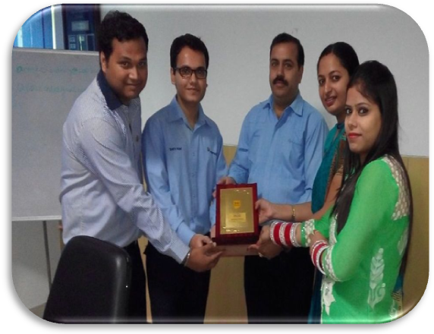
Industrial visit to Pepsico, Panipat for Management students
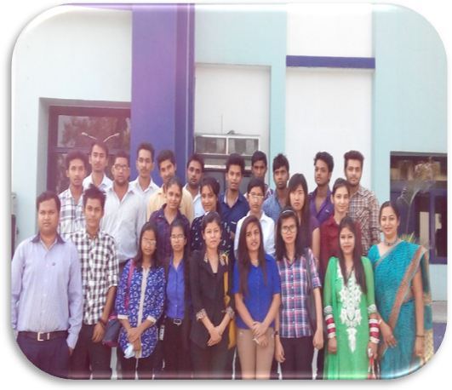
Samalkha Group of Institutions organized a one day Industrial trip for its Management students on 30th September 2014 in a renowned food & beverages company “Pepsico, Panipat”. Dr. Puja Waalia Mann (Dean, FOM), Mrs. Pooja Batra (Faculty of Management) accompanied the students during the visit.
On behalf of Pepsico, Panipat, a warm welcome was accorded by the HR Department. Mr. Saurabh (Assistant HR Manager) interacted with students and gave them a brief profile of the company, its production process and material handling department and other allied departments. He also enunciated about the recruitment process in their company, discussed the marketing strategies they adopt as well as the welfare activities for the employees etc.
Mr. Anant Choudhary (Mechanical engineer) took the students at production plant. The students were explained about the production Process of Pepsi, Slice, Mountain Dew etc. The unique business plan of this company is to recycle the water and also to focus on the waste management system.
Dr. Puja Waalia Mann, Dean, Faculty of Management, SGI said "These industrial visit are very beneficial to the management students to gain hands on experience in a large scale manufacturing unit and its management at all levels like HR, Materials, Stores, Production, Finance and Marketing etc.".
At the end Mr. Shivam (HR manager) responded to all the queries of the students.
Finally, a souvenir on behalf of SGI was given to the Plant head- Pepsico by Dean, Faculty of Management SGI.

